**g-0 (no effects)**

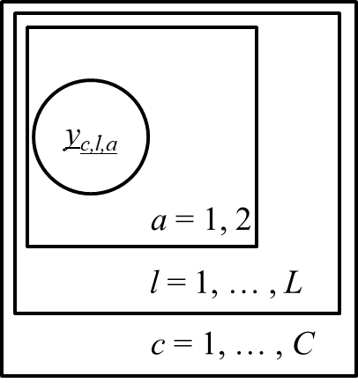

Model:



Where:







#for g-0

#plots tau

plot(density(sim.sample[[1]][,"tau"]), ylab="density", xlab="tau", main="")

#plots shape

plot(density(exp(sim.sample[[1]][,"log.Mu"])*exp(sim.sample[[1]][,"log.Mu"])*sim.sample[[1]][,"tau"]), ylab="density", xlab="Shape", main="")

observedShape <- density(exp(sim.sample[[1]][,"log.Mu"])*exp(sim.sample[[1]][,"log.Mu"])*sim.sample[[1]][,"tau"])

shapeMode <- observedShape$x[which.max(observedShape$y)]

#shapeMode = 1.273915

#plots rate

plot(density(exp(sim.sample[[1]][,"log.Mu"])*sim.sample[[1]][,"tau"]), ylab="density", xlab="Rate", main="")

observedRate <- density(exp(sim.sample[[1]][,"log.Mu"])*sim.sample[[1]][,"tau"])

rateMode <- observedRate$x[which.max(observedRate$y)]

#rateMode = 0.0003441744

x <- seq(1, 10000, length = 10000)

binSize <- 400

#plots the histogram of observed peak heights against fitted gamma curve

hist(data.df$obs, xlim=c(0,10000), breaks=seq(1, 40000, binSize), xlab="height(rfu)", ylab="count", main="O(histogram) vs E (modelled gamma)")

lines(x, binSize*length(data.df$obs)*dgamma(x, shape = shapeMode, rate = rateMode))

#plots observed vs expected peak heights

plot(log10(data.df$obs), log10(colMeans(sim.sample[[1]][,grep("pred", colnames(sim.sample[[1]]))])), xlab="log10(Observed height)", ylab="log10(expected height)", main="", xlim=c(2,5), ylim=c(2,5))

abline(coef = c(0,1))

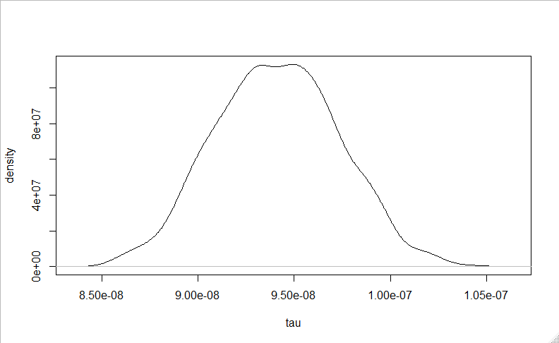

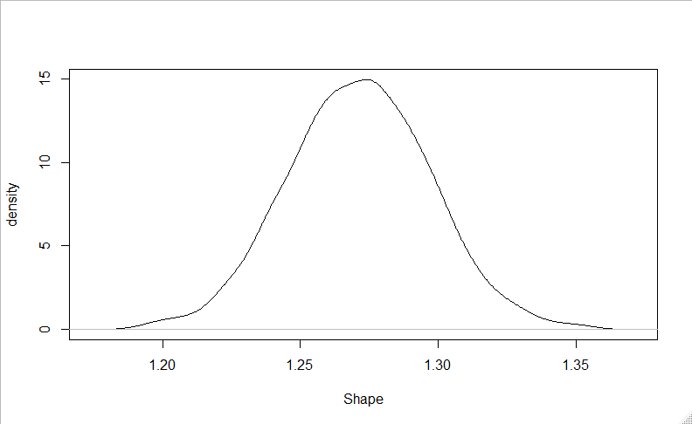

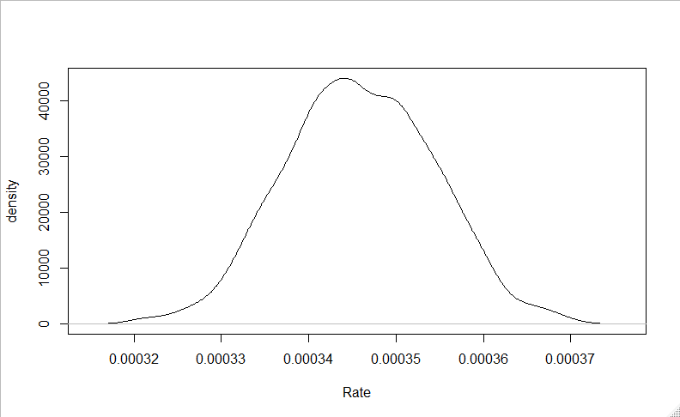

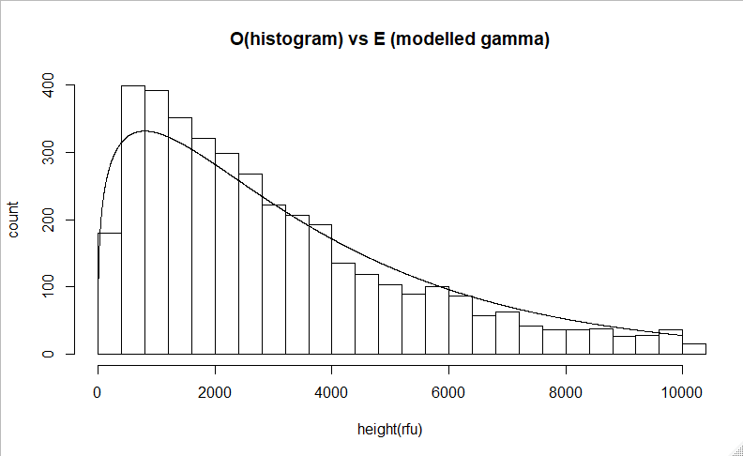

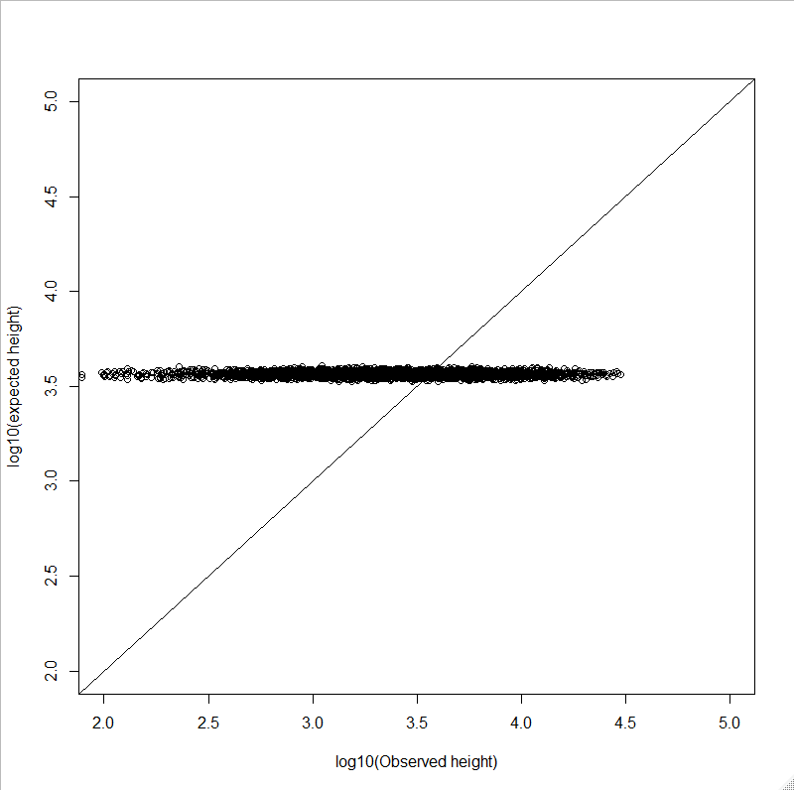

**g-1 (+ profile effect, τ)**

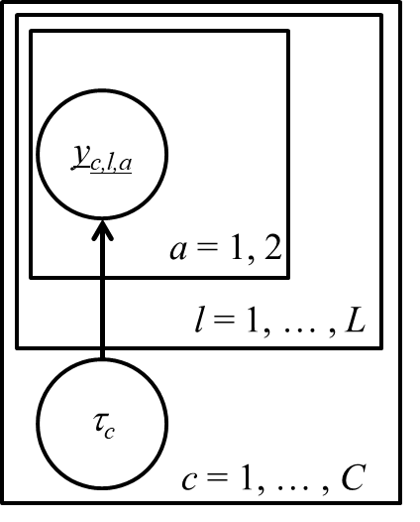

Model:



Where:













#for g-0

#plots profile effects

boxplot(as.matrix(sim.sample[[1]][,grep("profile", colnames(sim.sample[[1]]))]))

abline(h=0)

#aph vs profile effect

aveLogPeakHeight = data.df %>%

group_by(prof) %>%

summarise(alph = mean(log(obs), na.rm = TRUE)) %>%

pull(alph)

#plots locus effect vs aph

plot(aveLogPeakHeight, colMeans(sim.sample[[1]][,grep("profile", colnames(sim.sample[[1]]))]), xlab = "log(aph)", ylab = "profile effect (tau_c)")

#plots observed vs expected peak heights

plot(log10(data.df$obs), log10(colMeans(sim.sample[[1]][,grep("pred", colnames(sim.sample[[1]]))])), xlab="log10(Observed height)", ylab="log10(expected height)", main="", xlim=c(2,5), ylim=c(2,5))

abline(coef = c(0,1))

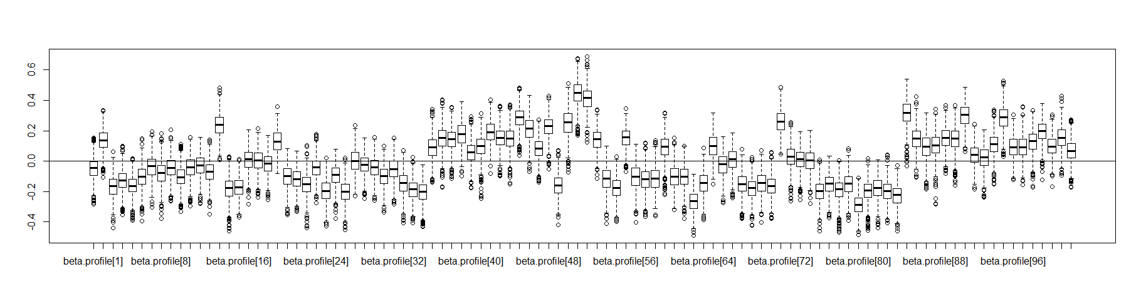

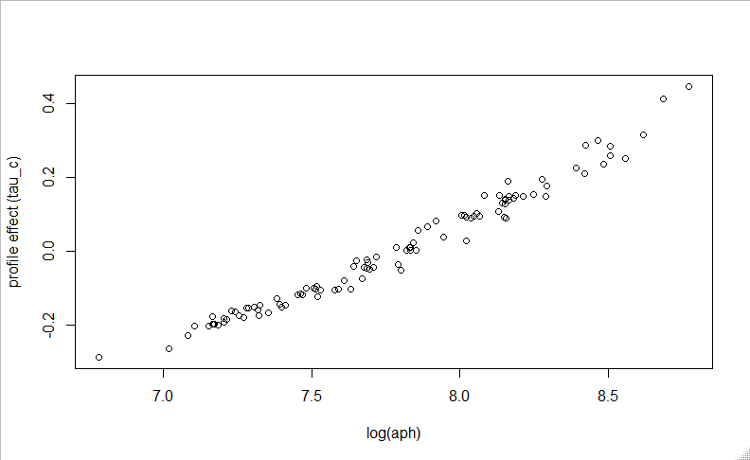

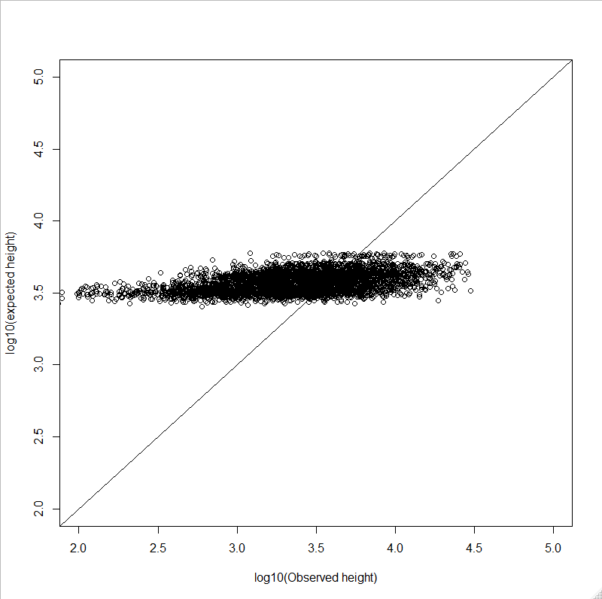

**g-2 (+ locus effect, α)**

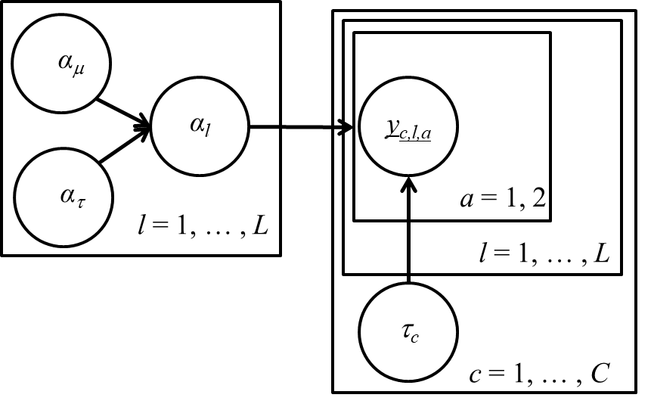

Model:



Where:



















#for g-2

#plots locus effects

boxplot(as.matrix(sim.sample[[1]][,grep("alpha.locus", colnames(sim.sample[[1]]))]))

abline(h=0)

#aph_perlocus vs profile effect

aveLogPeakHeightPerLocus = data.df %>%

group_by(loc) %>%

summarise(alph = mean(log(obs), na.rm = TRUE)) %>%

pull(alph)

#plots locus effect vs aph

plot(aveLogPeakHeightPerLocus , colMeans(sim.sample[[1]][,grep("alpha.locus", colnames(sim.sample[[1]]))]), xlab = "log(aph by locus)", ylab = "locus effect (alpha_l)")

#plots observed vs expected peak heights

plot(log10(data.df$obs), log10(colMeans(sim.sample[[1]][,grep("pred", colnames(sim.sample[[1]]))])), xlab="log10(Observed height)", ylab="log10(expected height)", main="", xlim=c(2,5), ylim=c(2,5))

abline(coef = c(0,1))

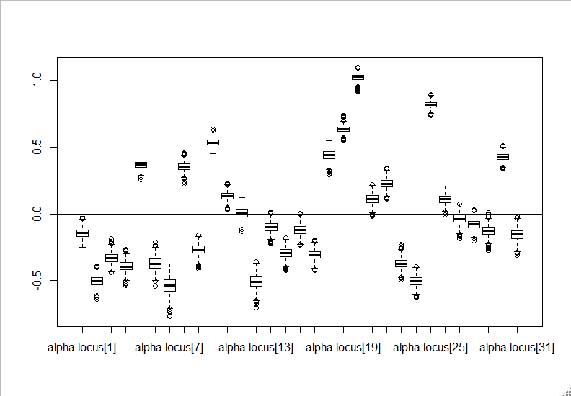

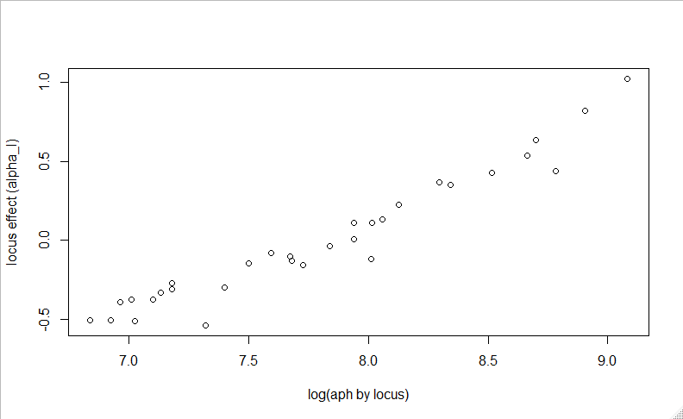

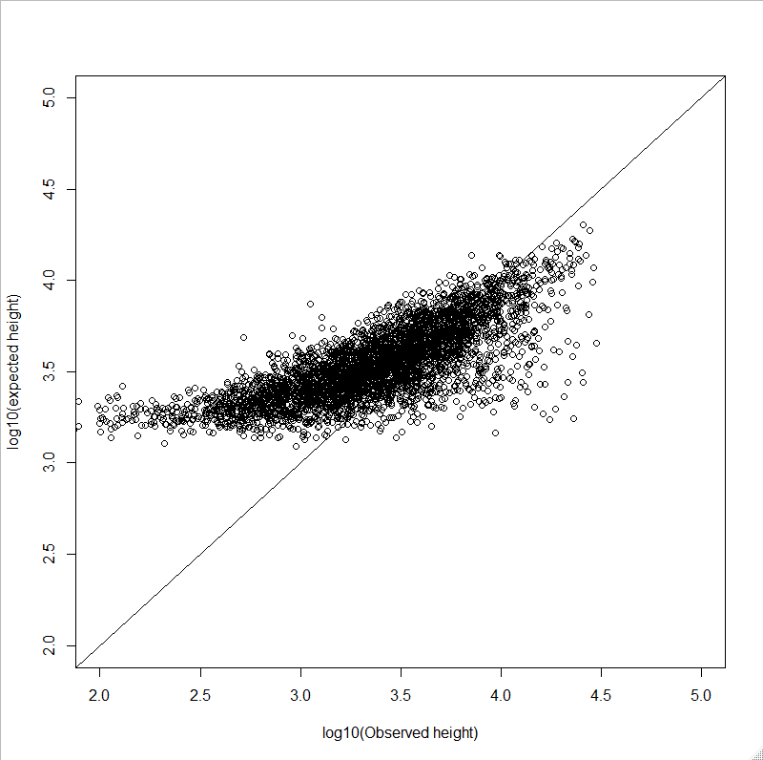

**g-3 (+ dye effect, δ + dose, X)**

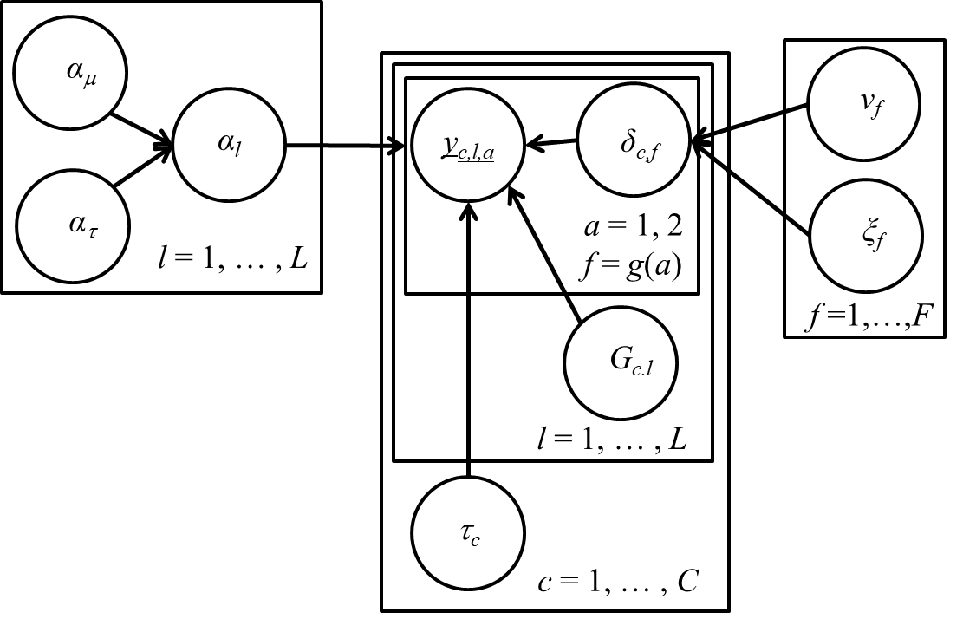

Model:



Where:





















*I* is an indicator function





#for g-3

#plots dye effects

boxplot(as.matrix(sim.sample[[1]][,grep("gamma.dye", colnames(sim.sample[[1]]))]))

abline(h=0)

#aph_perdye vs profile effect

aveLogPeakHeightPerDye = data.df %>%

group_by(dye) %>%

summarise(alph = mean(log(obs), na.rm = TRUE)) %>%

pull(alph)

#plots locus effect vs aph

plot(aveLogPeakHeightPerDye , colMeans(sim.sample[[1]][,grep("gamma.dye", colnames(sim.sample[[1]]))]), xlab = "log(aph by dye)", ylab = "dye effect (delta_l)")

#plots observed vs expected peak heights

plot(log10(data.df$obs), log10(colMeans(sim.sample[[1]][,grep("pred", colnames(sim.sample[[1]]))])), xlab="log10(Observed height)", ylab="log10(expected height)", main="", xlim=c(2,5), ylim=c(2,5))

abline(coef = c(0,1))

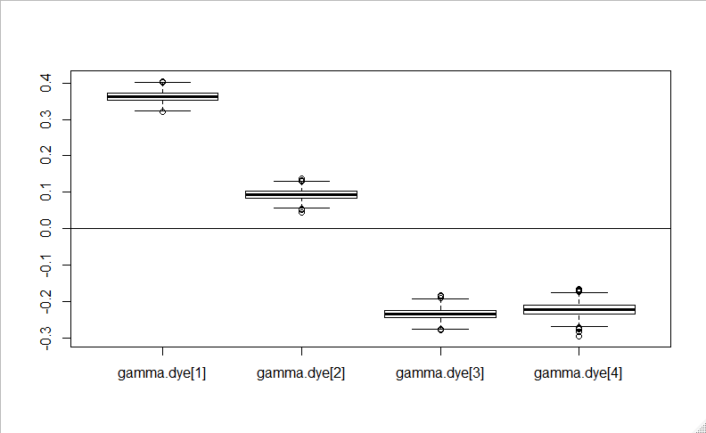

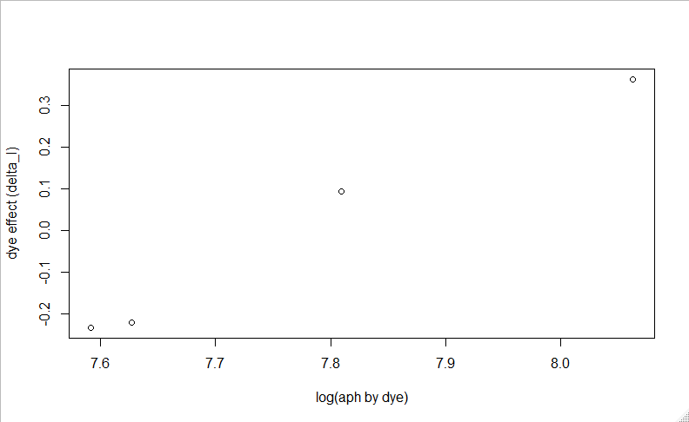

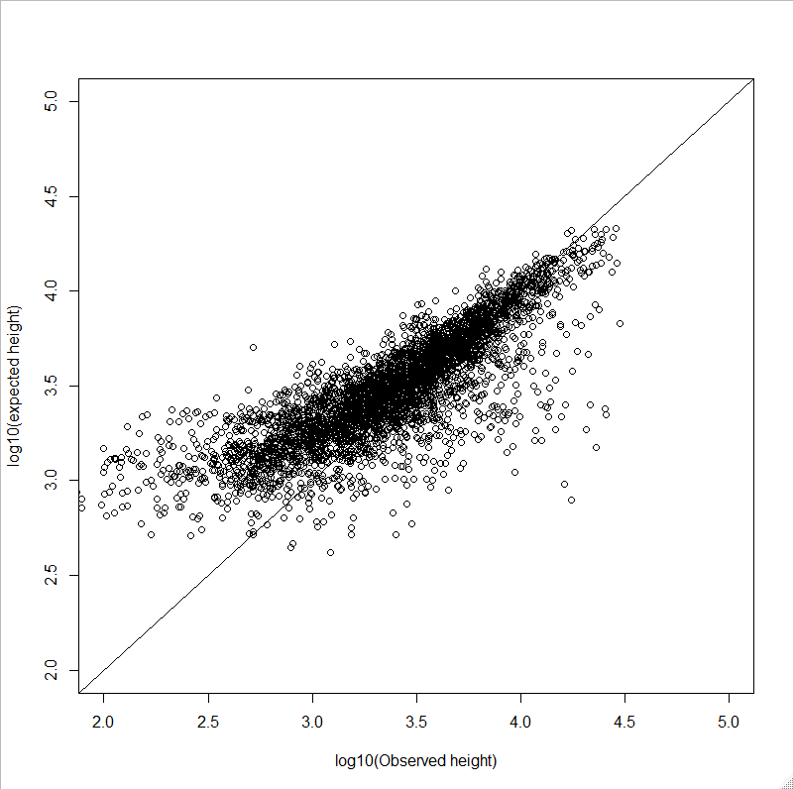

**g-4 (+ variance effect, V)**

Not sure what the panel plot looks like for this????

Model:



Where:

 where is the average peak height of the profile



And remainder of model is the same

plot(density(sim.sample[[1]][,"tau0"]), ylab="density", xlab="tau0", main="")

plot(density(sim.sample[[1]][,"tau1"]), ylab="density", xlab="tau1", main="")

#plots observed vs expected peak heights

plot(log10(data.df$obs), log10(colMeans(sim.sample[[1]][,grep("pred", colnames(sim.sample[[1]]))])), xlab="log10(Observed height)", ylab="log10(expected height)", main="", xlim=c(2,5), ylim=c(2,5))

abline(coef = c(0,1))

